**8.7 Label :-**

A Label object is a component for placing text in a container. A label displays a single line of read-only text. The text can be changed by the application, but a user cannot edit it directly.

A displayed label object is known as the Label. Most of the times label is used to demonstrate the significance of the other parts of the GUI. It helps to display the functioning of the next text field. A label is also restricted to a single line of text as a button. The example below shows the significance of Label.

In this example, we have added two labels in the applet as shown.

**import** java.awt.*;

**class** LabelExample{

**public** **static** **void** main(String args[]){

    Frame f= **new** Frame("Label Example");

    Label l1,l2;

    l1=**new** Label("First Label.");

    l1.setBounds(50,100, 100,30);

    l2=**new** Label("Second Label.");

    l2.setBounds(50,150, 100,30);

    f.add(l1); f.add(l2);

    f.setSize(400,400);

    f.setLayout(**null**);

    f.setVisible(**true**);

}

}

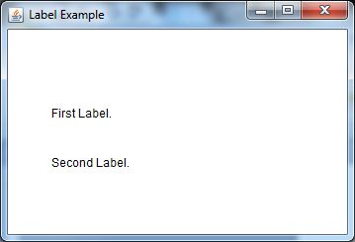

import java.awt.*;

import java.applet.Applet;

/*

<head>

<APPLET CODE="Applet1.class" HEIGHT=400 WIDTH=400>

</APPLET>

</body>

*/

public class Applet1 extends Applet {

public void init() {

add(new Label("label one"));

add(new Label("label two", Label.RIGHT));

}

}

Here is the output:

C:\j2sdk1.4.1\bin>javac Applet1l.java

C:\j2sdk1.4.1\bin> appletviewer Applet1l.java